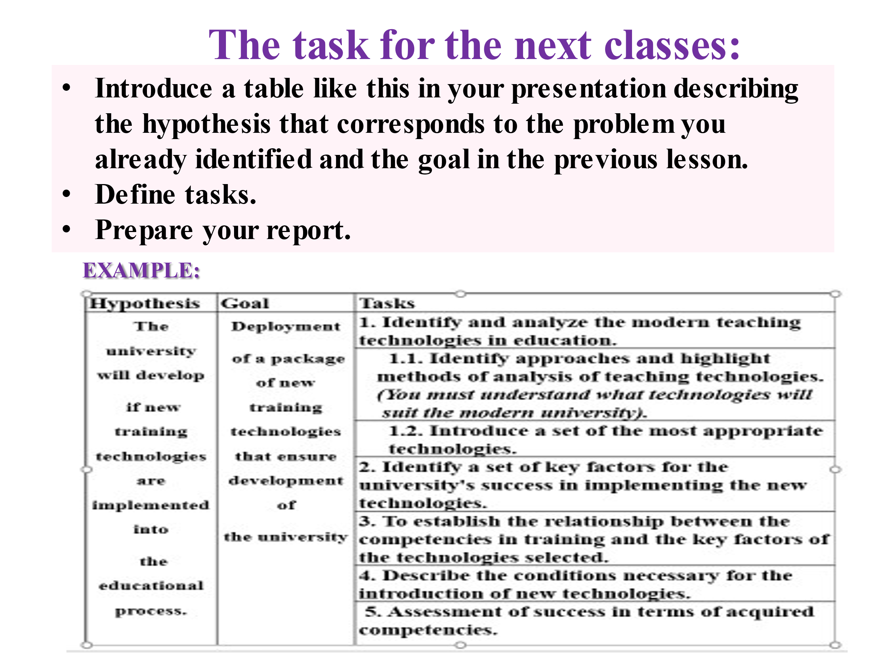

Задание для следующих занятий:

• Представьте в своей презентации таблицу, подобную этой, описывающую

гипотезу, которая соответствует проблеме, которую вы уже определили, и цели на предыдущем уроке.

• Определите задачи.

• Подготовьте свой отчет.

The task for the next classes:

• Introduce a table like this in your presentation describing

the hypothesis that corresponds to the problem you

already identified and the goal in the previous lesson.

• Define tasks.

• Prepare your report.

EXAMPLE:

Hypothesis Goal

Tasks

The university of a package will develop ofnew if new training training technologies

technologies that ensure are implemented

edueational

Deployment

1. Identify and analyze the modern teaching

technologies in education.

1. 1. Identify approaches and highlight

methods of analysis of teaching technologies.

(You must understand what technologies will

suit the modern university).

1.2. Introduce a set of the most appropriate

technologies.

2. Identify a set of key factors for the

development university's success in implementing the new technologies.

of

into

3. To establish the relationship between the the university competencies in training and the key factors of the

process.

the technologies selected.

4. Describe the conditions necessary for the

introduction of new technologies.

5. Assessment of success in terms of acquired

competencies.